Financial Institutions
# Source: AI Source: Provided by: [Data Path: Persons Table -> ID Column: 1, Name_En Column: Motasem Essam] -> From: [ChatGPT] on [1/21/2026]
In a payment system, Financial Institutions are the backbone of trust and money movement. These are regulated entities — like banks, credit unions, and electronic money institutions (EMIs) — that hold, process, transfer, and settle the funds involved in every payment.

🧠 Simple Definition
# Source: AI Source: Provided by: [Data Path: Persons Table -> ID Column: 1, Name_En Column: Motasem Essam] -> From: [ChatGPT] on [1/21/2026]
A financial institution is a licensed organization that manages money on behalf of individuals and businesses — enabling transactions, storage, settlement, and reconciliation within a payment system.

🏛️ Examples of Financial Institutions
# Source: AI Source: Provided by: [Data Path: Persons Table -> ID Column: 1, Name_En Column: Motasem Essam] -> From: [ChatGPT] on [1/21/2026]
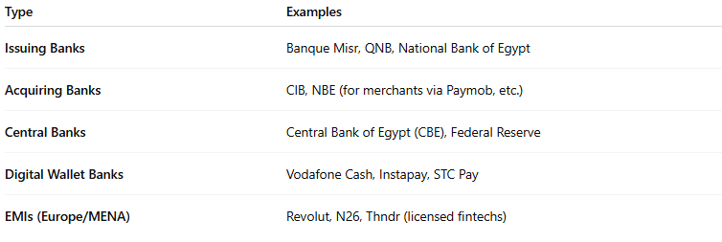
Type | Examples
Issuing Banks | Banque Misr, QNB, National Bank of Egypt
Acquiring Banks | CIB, NBE (for merchants via Paymob, etc.)
Central Banks | Central Bank of Egypt (CBE), Federal Reserve
Digital Wallet Banks | Vodafone Cash, Instapay, STC Pay
EMIs (Europe/MENA) | Revolut, N26, Thndr (licensed fintechs)

🔄 Roles in a Payment System
# Source: AI Source: Provided by: [Data Path: Persons Table -> ID Column: 1, Name_En Column: Motasem Essam] -> From: [ChatGPT] on [1/21/2026]
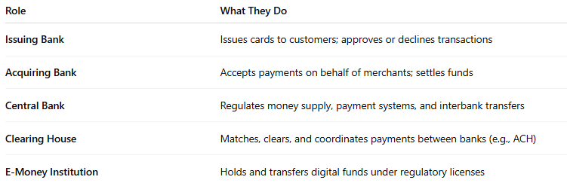

Role | What They Do
Issuing Bank | Issues cards to customers; approves or declines transactions
Acquiring Bank | Accepts payments on behalf of merchants; settles funds
Central Bank | Regulates money supply, payment systems, and interbank transfers
Clearing House | Matches, clears, and coordinates payments between banks (e.g., ACH)
E-Money Institution | Holds and transfers digital funds under regulatory licenses

💡 Why They Matter in Payments
# Source: AI Source: Provided by: [Data Path: Persons Table -> ID Column: 1, Name_En Column: Motasem Essam] -> From: [ChatGPT] on [1/21/2026]
- Trust: They are regulated, licensed, and audited.
- Liquidity: They provide the actual funds used in payments.
- Settlement: They ensure that funds move from payer to payee accounts.
- Dispute handling: They handle fraud, chargebacks, and reversals.
- Compliance: They enforce AML (Anti-Money Laundering) and KYC (Know Your Customer) rules.

📦 In a Real Payment Flow Example
# Source: AI Source: Provided by: [Data Path: Persons Table -> ID Column: 1, Name_En Column: Motasem Essam] -> From: [ChatGPT] on [1/21/2026]
🧾 You Pay Online Using a Visa Card:
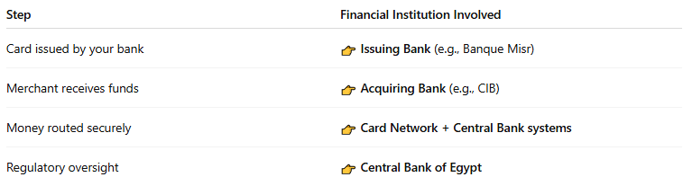
Step | Financial Institution Involved
Card issued by your bank | 👉 Issuing Bank (e.g., Banque Misr)
Merchant receives funds | 👉 Acquiring Bank (e.g., CIB)
Money routed securely | 👉 Card Network + Central Bank systems
Regulatory oversight | 👉 Central Bank of Egypt

🔐 Security & Legal Roles
# Source: AI Source: Provided by: [Data Path: Persons Table -> ID Column: 1, Name_En Column: Motasem Essam] -> From: [ChatGPT] on [1/21/2026]
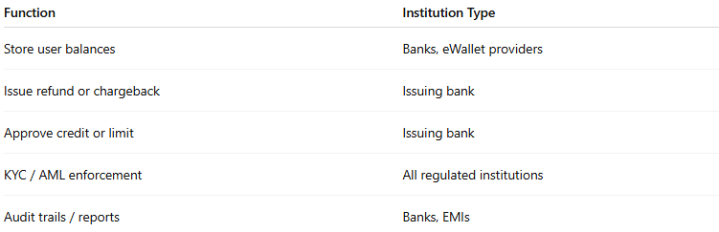

Function | Institution Type
Store user balances | Banks, eWallet providers
Issue refund or chargeback | Issuing bank
Approve credit or limit | Issuing bank
KYC / AML enforcement | All regulated institutions
Audit trails / reports | Banks, EMIs

🧠 Summary
# Source: AI Source: Provided by: [Data Path: Persons Table -> ID Column: 1, Name_En Column: Motasem Essam] -> From: [ChatGPT] on [1/21/2026]


Component | Financial Institutions
What they are | Licensed bodies managing and moving money
Why they matter | Provide trust, regulation, compliance, and liquidity
Examples | Issuing & acquiring banks, central banks, EMIs

